Synopsis Report
Design and Analysis of Algorithms – PBL (Project Based Learning)
Project Challenge #29: Non-Fractional Relief Packing using Branch and Bound
Primary Algorithm: Branch and Bound
Application: Optimizing indivisible relief packages under limited vehicle capacity
Group Lead: Navvya Bhardwaj
Group Members: Parth Bhatt, Bhavya Srivastava, Mehak Dilawar

How we have divided the work
Team Member | Assigned Project Role | Primary Deliverables & Rubric Ownership
Mehak | Core Algorithm & Solver Lead | Best-First Branch and Bound implementation, fractional upper-bound relaxation, state tracking, and search-tree trace logging.
Parth | Baselines & Theoretical Analysis Lead | 0/1 Dynamic Programming and Greedy density baselines, formal upper-bound invariant proof, complexity analysis, and small-instance hand verification.
Bhavya | Dataset Engineering & Hygiene Lead | Three-scale dataset curation (small, medium, large), schema enforcement, data sanitizer for missing/duplicate/invalid records, and 5+ edge cases.
Navvya | Dashboard, Profiling & Reproducibility Lead | Explainable decision UI/CLI report, empirical runtime and node-count benchmarking plots, streaming update service, and reproducible environment setup.

Milestone / Checkpoint | Required Demonstration & Verification Criteria | Lead Presenter(s)
Checkpoint 1 (3-Minute Model Pitch) | Present formal 0/1 mathematical model, operational user constraints, fractional upper-bound relaxation formula, and three-scale dataset schema. | Parth & Mehak
Checkpoint 2 (Manual Verification) | Walk through the 5-item hand-verified trace tree node-by-node, demonstrating exact agreement between manual calculation, DP baseline, and B&B prototype. | Mehak & Bhavya
Checkpoint 3 (Profiling & Hygiene) | Demonstrate automated data sanitization, all 5 edge cases, invalid-input handling, and empirical runtime/node-pruning plots across scales. | Bhavya & Navvya
Final Judging Demo (5-Minute Live Defense) | Live dashboard run, paradigm defense (when B&B beats DP on high-precision weights and when DP/Greedy is preferable), complexity defense, and limitations. | All 4 Members (Mehak, Parth, Bhavya, Navvya)

1. Abstract
During disaster relief operations, transport vehicles have limited carrying capacity while many essential supply packages may need to be delivered. This project proposes a simple decision-support prototype that selects a set of complete (non-fractional) relief packages so that the total relief priority is maximized without exceeding the available vehicle capacity. The problem is modeled as a 0/1 Knapsack problem and solved using the Branch and Bound technique. The system will accept a small structured dataset containing item name, weight and relief-priority score, validate the input, calculate an optimal packing plan, and display the selected items, total weight, total priority score and basic search statistics. A brute-force method will be used on small test cases as a baseline to verify correctness and compare efficiency.

2. Introduction
In emergency situations such as floods, earthquakes or landslides, relief teams may have more supplies than a single truck or aircraft can carry. Choosing packages only by weight or by apparent importance can waste limited capacity or exclude a better combination of essential supplies. Since a package such as a medicine kit, food box or water kit normally has to be transported as a complete unit, the selection is non-fractional.
The proposed system represents each package using its weight and a relief-priority score. Branch and Bound explores include/exclude choices for the packages but avoids unnecessary work by pruning branches that cannot improve the best solution already found. This keeps the project closely connected to the Design and Analysis of Algorithms syllabus while giving the algorithm a measurable real-world objective.

3. Problem Statement
Given a set of indivisible relief packages and a vehicle with limited weight capacity, determine which packages should be loaded so that the total relief-priority score is as high as possible while the total weight remains within the capacity.
Input | Decision | Output
Relief items, item weights, priority scores and vehicle capacity | For every item: select it (1) or do not select it (0) | Optimal selected items, total weight, total priority and remaining capacity

4. Objectives
- Model relief packing as a 0/1 Knapsack optimization problem.
- Implement Branch and Bound to find the optimal non-fractional packing.
- Use a simple CSV dataset with item ID, item name, weight and relief-priority score.
- Validate common input problems such as empty data, duplicate IDs, missing values and invalid weights.
- Compare the Branch and Bound result with brute force for small controlled inputs.
- Measure basic performance such as runtime, nodes explored and nodes pruned.
- Present the result in a simple command-line interface or lightweight dashboard that a non-specialist can understand.

5. Simple Mathematical Model
For each relief package i, let wᵢ be its weight, vᵢ its relief-priority score, and xᵢ indicate whether the package is selected.
\max \sum_i v_i x_i \quad \text{subject to} \quad \sum_i w_i x_i \le W, \quad x_i \in \{0,1\}
Here, W is the maximum vehicle capacity. The binary value xᵢ makes the model non-fractional: a package is either loaded completely or not loaded.

6. Proposed Dataset
A small CSV dataset will be created for the prototype. The priority score is a simple numerical representation of the relative usefulness or urgency of an item; the project does not attempt to predict this score using AI.
ID | Relief Item | Weight (kg) | Priority Score
R01 | Medicine Kit | 5 | 100
R02 | Water Kit | 10 | 90
R03 | Food Box | 12 | 85
R04 | Blanket Pack | 9 | 60
R05 | Hygiene Kit | 6 | 55

7. Proposed Methodology / Algorithm
The implementation will use Best-First Branch and Bound. Items are first ordered by priority-to-weight ratio. Each search node represents decisions made up to a particular item and stores the current weight, current priority value and an optimistic upper bound. The bound may temporarily use a fractional part of the next item only to estimate the best possible value of a branch; the final solution itself always contains complete packages.
- Read the CSV dataset and vehicle capacity.
- Validate the records and reject or report invalid entries.
- Sort valid items by priority/weight ratio.
- Create the root node with zero weight and zero value.
- Calculate an upper bound for the node and place promising nodes in a priority queue.
- For the next item, create two branches: include the item and exclude the item.
- If an included branch is feasible and improves the best value, update the best solution.
- Prune any node whose weight exceeds capacity or whose upper bound cannot beat the current best value.
- Repeat until no promising node remains.
- Display the selected packages and performance statistics, then compare with brute force on small cases.

Implementation Flowchart
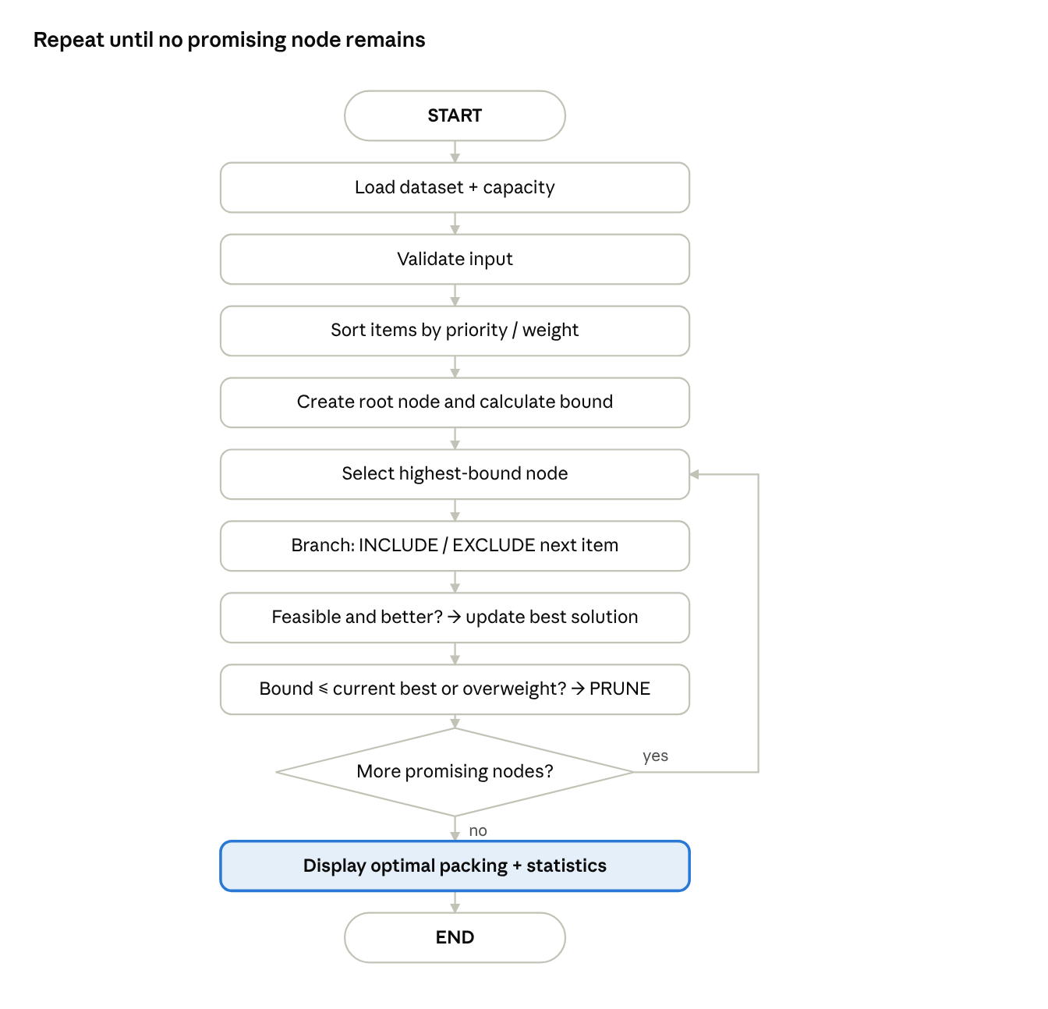
implementation flowchart · 12 steps, 1 loop

8. Correctness and Complexity Plan
Correctness will be checked first on a small example whose possible combinations can be verified manually. The same input will also be solved using brute force. The Branch and Bound answer should match the brute-force optimum. During the search, the best recorded value always represents the best feasible packing found so far, and a branch is discarded only when its optimistic bound cannot improve that value.
The worst-case running time remains exponential, O(2ⁿ), because Branch and Bound may still explore many include/exclude combinations. In practice, pruning can reduce the number of nodes examined. Runtime and node counts will therefore be measured for increasing input sizes instead of claiming that the algorithm is always fast.

9. Testing and Evaluation
- Normal small dataset with a known optimum.
- Empty dataset.
- Zero vehicle capacity.
- All packages heavier than the capacity.
- Duplicate or missing/invalid record.
- Tie or exact-capacity case.
- A larger stress-test dataset to observe runtime and pruning.
The final comparison will report objective value, feasibility, runtime, and (for Branch and Bound) nodes explored/pruned. This directly supports the judging criteria of correctness, complexity analysis, empirical efficiency, prototype quality and reproducibility.

10. Expected Output / Prototype
The first prototype will be intentionally simple. It will read the dataset, accept vehicle capacity, run Branch and Bound and print a clear result such as selected relief items, total packed weight, unused capacity, total relief-priority score, runtime, nodes explored and nodes pruned. If time permits, the same information can be shown through a lightweight Streamlit dashboard without changing the core algorithm.

11. Expected Outcome and Future Scope
The expected outcome is a reproducible prototype that demonstrates how Branch and Bound can support a practical relief-packing decision while guaranteeing an optimal solution for the stated model. The initial version considers one vehicle and one weight constraint. Future extensions may include multiple vehicles, volume limits, package expiry, destination demand or fairness constraints, but these are outside the scope of the first implementation.

12. Tools and Technologies
Component | Proposed Choice
Programming language | C/C++
Dataset | CSV
Core algorithm | Best-First Branch and Bound
Baseline | Brute Force (small inputs)
Interface | Command line; optional Streamlit dashboard
Version control / sharing | GitHub

13. Alignment with PBL Evaluation
Rubric Area | How the Project Addresses It
Problem understanding & modelling | Formal 0/1 model linked to a relief-transport scenario.
Algorithmic correctness & justification | Branch and Bound, bound/pruning logic, manual verification and brute-force check.
Complexity & empirical efficiency | O(2ⁿ) worst case plus measured runtime and node pruning.
Prototype & reproducibility | CSV input, modular code, README and repeatable test cases.
Innovation / impact | A simple decision-support use case for limited relief transport capacity.
Communication & teamwork | Clear output, short demo, documentation and contribution record.

